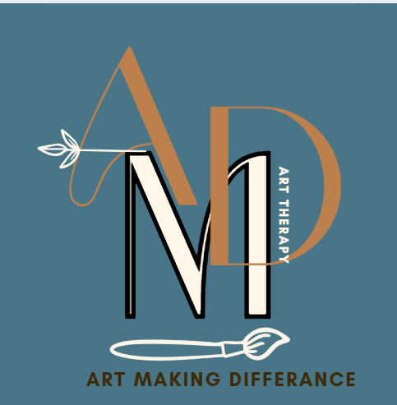
COMMUNITY INTEREST COMPANY
NORTH CUMBRIA – Eden Valley
ARt Making Difference Community Interest company
Registered address: Curlew Cottage Renwick CA10 1JL
Company Number
16424303
Health and Safety Policy
Updated 21st June 2025
Review: June 2025

Health and Safety Policy
Art Making Difference CIC is committed to ensuring the health, safety, and welfare of all staff, volunteers, clients, and visitors. This policy outlines our approach to managing health and safety in accordance with UK legislation and best practice.
Note: All policies and procedures outlined in this document must align with the health and safety protocols of the premises where services are delivered.

1. Responsibilities
The elected Committee (Chairperson, Secretary, Treasurer) holds overall responsibility for health and safety. Day-to-day implementation is overseen by the Steering Group, which includes staff, volunteers, and clients. All individuals are expected to take reasonable care of their own health and safety and report concerns promptly.

2. Risk Assessment Principles
Regular risk assessments will be conducted for all activities, premises, and equipment. These assessments will identify hazards, evaluate risks, and implement control measures. Risk assessments will be reviewed annually or when significant changes occur. A copy of the venue risk assessment will be obtained prior to sessions and be forwarded to the session lead.

3. Safeguarding
Art Making Difference CIC is committed to safeguarding children, young people, and vulnerable adults. All staff and volunteers must complete safeguarding training and adhere to our Safeguarding Policy. DBS checks will be carried out where required.

4. Emergency Procedures
Emergency procedures, including fire evacuation plans and first aid arrangements, will be clearly displayed and communicated. All staff and volunteers will be briefed on emergency protocols during induction.

5. Training
All staff and volunteers will receive appropriate health and safety training relevant to their roles. Training records will be maintained and updated regularly.

6. Reporting Incidents
All accidents, near misses, and health and safety concerns must be reported using the Incident Reporting Form. Reports will be reviewed by the Committee and Steering Group to identify trends and implement improvements.

7. Review Process
This policy will be reviewed annually by the Committee and Steering Group, or sooner if required by changes in legislation or organisational activities.

8. Operational Procedures
All activities undertaken by Art Making Difference CIC must be subject to a suitable risk assessment. This involves identifying potential hazards and implementing measures to mitigate risks, unless such measures are deemed grossly disproportionate.
All equipment must be inspected for signs of damage prior to use. Damaged

equipment must be clearly labelled 'NOT TO BE USED' and reported for repair.
When using or storing potentially hazardous materials (e.g., cleaning fluids) always comply with the manufacturer’s health and safety guidance.
- Ensure that all areas under the control of the Service setting are clean, tidy and free from clutter.
- Ensure that exit routes from buildings under the control of the Service setting are kept clear.
- Ensure that periodic checks are carried out on electrical equipment which is under the control of the Service setting.
- Ensure that a COSHH risk assessment review is carried out at least annually and that safety data sheets (SDSs) are updated whenever a new COSHH substance is purchased.
- Ensure that an annual gas safety check is carried out.
- Ensure that periodic checks are done on the fabric of any building which is under the control of the Service setting.
- Ensure settings have regular servicing of all fire extinguishers, and the fire alarm system and test alarm weekly.
- Any changes to the building structure must be checked against the Fire certificate.
- Ensure that an annual program of emergency evacuations is conducted for those premises routinely under the control of the Service setting.
- At least one of the staff or volunteers running any session must have up to date First Aid training.
- If any person behaves in a way which risks serious injury to themselves, or others, they can be excluded from the facilities under the control of the Service setting.

9. Incident Reporting Form
This form is used to report any incidents that occur during activities or operations of Art Making Difference CIC. It ensures compliance with health and safety regulations and supports appropriate follow-up actions.
Until an online incident reporting form Appendix 1. is developed, all incidents must be reported directly to the premises manager in accordance with the venue’s health and safety policy. Reports must also be forwarded to enquiries@artmakingdifference.co.uk. HSL = Health and Safety Lead Officer – Susan Morris

10. Related Policies
Where activities are delivered online or involve digital communication, Art Making Difference CIC will ensure that platforms used are secure and that personal data is handled in accordance with GDPR and our Data Protection Policy.

11. Digital Safety
Art Making Difference CIC is committed to ensuring that all environments and activities are accessible. Reasonable adjustments will be made to support individuals with disabilities or additional needs, in line with the Equality Act 2010.

12. Accessibility and Inclusion
Safeguarding procedures are integral to our health and safety framework. All staff and volunteers must follow safeguarding protocols when working with children, young people, or vulnerable adults, including reporting concerns and adhering to lone working guidelines.

13. Safeguarding Integration
Art Making Difference CIC recognises that health and safety encompass mental wellbeing. We are committed to fostering a supportive environment where staff, volunteers, and clients feel safe to express concerns. Mental health first aid awareness will be promoted, and regular wellbeing check-ins encouraged.

14. Accidents, Injuries & First Aid
All injuries sustained by a person in the Service setting, however minor, must be reported and recorded. These records are crucial to effective monitoring and revision of the policy. They must therefore be accurate and comprehensive.
Accident forms are kept in the Good Management File that will support all events and settings office.
First Aid boxes will be portable and kept within an identified place shared at the initial housekeeping introductions delivered at each group meeting or session delivery.
All First Aid boxes will be monitored to ensure that they are correctly stocked, listing the contents in each box. The HSL will be responsible for maintaining First Aid boxes and provisions.
First Aid must not be administered to anyone unless by a trained and qualified First Aider. It is the responsibility of the First Aider to decide whether an ambulance is necessary.

15. Control of Substances Hazardous to Health (COSHH)
Any business that requires their employees to be in any way in contact or exposed to any substances hazardous to health in the workplace needs to comply with the Control of Substances Hazardous to Health (COSHH) Regulations 2002 (amended 2004). Art Making Difference CIC recognises its duty in respect of these regulations.
A risk assessment should be undertaken before use of any potentially harmful substances to mitigate any risks, including provision of PPE. http://www.hse.gov.uk/coshh/basics/index.htm
The HSL will be responsible for identifying all substances that need a COSHH assessment.
The HSL will be responsible for undertaking COSHH assessments and for ensuring that records are kept and maintained where necessary.
The HSL will be responsible for ensuring that all actions identified in the assessments are implemented.
The HSL will be responsible for ensuring that all relevant employees are informed about the COSHH assessments and that appropriate training is given.
The HSL will check that new substances can be used safely before they are purchased.
The HSL will ensure that assessments are reviewed every year or when the work activity changes, whichever occurs soonest.
Most staff of Art Making Difference CIC will have cause to use COSHH at some point, and anyone using them must be made aware of the hazards involved. Anyone handling hazardous chemicals should always read instructions carefully and only use the substance as directed.
Everyone should take care not to allow chemicals to come into contact with their eyes, skin or clothing. In the event of contamination, they should use plenty of cold water to wash the area and seek medical advice and treatment without delay.
Please be aware that whilst certain substances may have their own COSHH regulations (which you must read if you use them), mixing with other materials may result in more hazardous material being produced. An example of this is bleach. In contact with other cleaners (and even other manufacturers bleaches), it can produce chlorine gas which is highly dangerous particularly when used in confined spaces like toilet cubicles or over sinks.
Below is sample warning signs used on product packaging or materials. Staff and volunteers should be familiar with these symbols. Appendix 2.

16. Risk Assessment Principles
Risk assessment starts with identifying risks and then establishing what can be done to avoid or reduce those risks. The purpose of risk assessment is to ensure that the risk to any individual is as low as reasonably practicable, usually referred to as ALARP. The concept of “reasonably practicable” lies at the heart of the UK health and safety system, it is a key part of the Health and Safety at Work Act (1974). ‘Reasonably practicable’ is a narrower term than ‘physically possible’, a calculation must be made where risk is placed on one scale and the sacrifice involved in averting the risk (whether in money, time or trouble) is placed in the other. The legal presumption is that the risk reduction measure should be implemented. However, if there is a gross disproportion between them, the risk being insignificant in relation to the sacrifice, the sacrifice does not need to be made. The ALARP process is about adopting measures except where they are ruled out because they involve grossly disproportionate sacrifices. Extreme examples might be:
Of course, in reality many decisions about risk and the controls that achieve ALARP are not so obvious. Factors come into play such as ongoing costs set against remote chances of one-off events, or daily expense and supervision time required to ensure that, for example, employees wear ear defenders set against a chance of developing hearing loss at some time in the future. It requires judgment. There is no simple formula for calculating what is ALARP.

Related Policies and Documents:
Fire Procedures
Fire Risk Assessment Venue Risk Assessments

17. Premises-Specific Health and Safety Responsibilities
Health and safety responsibilities vary depending on the premises used for delivery service. All staff, volunteers, and session leads must comply with the venue’s health and safety policies, fire regulations, and must review any relevant risk assessments and emergency procedures prior to service delivery.

APPENDIX 1
Incident Reporting Form

This form is used to report any incidents that occur during activities or operations of Art Making Difference CIC. It ensures compliance with health and safety regulations and supports appropriate follow-up actions.
Date of Incident
Time of Incident
Location of Incident
Person(s) Involved
Description of Incident
Immediate Actions Taken
Witness(es)
Follow-up Actions Required
Signature of Person Reporting
Date of Report

Premises-Specific Health and Safety Responsibilities
Health and safety responsibilities are dependent on the premises used for service delivery. All staff, volunteers, and session leads must adhere to the health and safety policies and fire regulations of the premises in which activities are conducted. Prior to delivering any services, individuals must have reviewed and understood any relevant venue-specific risk assessments and emergency procedures. This ensures compliance with local safety standards and supports the wellbeing of all participants.

Safety Shouldn't Stumble on Paperwork: A Guide to Using Microsoft Forms for Incident Reporting

APPENDIX 2
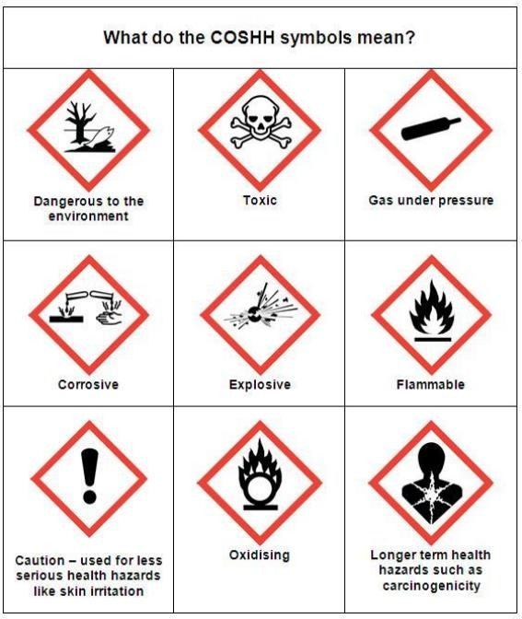

Risk Assessment
Risk assessment starts with identifying risks and then establishing what can be done to avoid or reduce those risks. The purpose of risk assessment is to ensure that the risk to any individual is as low as reasonably practicable, usually referred to as ALARP. The concept of “reasonably practicable” lies at the heart of the UK health and safety system, it is a key part of the Health and Safety at Work Act (1974). ‘Reasonably practicable’ is a narrower term than ‘physically possible’, a calculation must be made where risk is placed on one scale and the sacrifice involved in averting the risk (whether in money, time or trouble) is placed in the other. The legal presumption is that the risk reduction measure should be implemented. However, if there is a gross disproportion between them, the risk being insignificant in relation to the sacrifice, the sacrifice does not need to be made. The ALARP process is about adopting measures except where they are ruled out because they involve grossly disproportionate sacrifices. Extreme examples might be:
Of course, many decisions about risk and the controls that achieve ALARP are not so obvious. Factors come into play such as ongoing costs set against remote chances of one-off events, or daily expense and supervision time required to ensure that, for example, employees wear ear defenders set against a chance of developing hearing loss at some time in the future. It requires judgment. There is no simple formula for calculating what is ALARP.

Related Policies and Documents:
COSHH Risk Assessment COSHH SDSs
Fire Procedures
Fire Risk Assessment Venue Risk assessments

Reviewed-  Signed –  Director | Reviewed- updated Fist Aid section)  Signed – | Reviewed- Signed – | Reviewed- Signed – | Reviewed- Signed –

