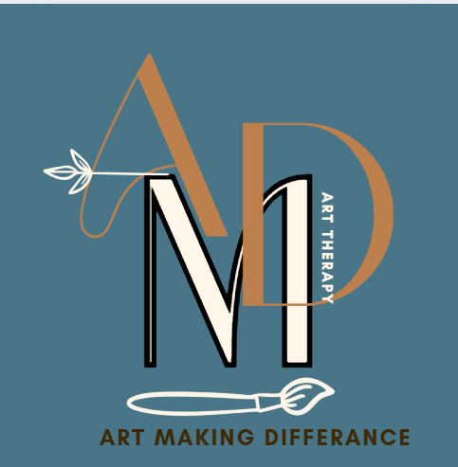
COMMUNITY INTEREST COMPANY
NORTH CUMBRIA – Eden Valley
ARt Making Difference Community Interest company
Registered address: Curlew Cottage Renwick CA10 1JL
Company Number
16424303
General Data Protection Regulation (GDPR) Policy
Updated 21st June 2025
Review: June 2025

General Data Protection Regulation (GDPR) Policy

Introduction
Art Making Difference CIC is committed to protecting the personal data of clients, staff, volunteers, and associated individuals. This policy outlines how Art Making Difference CIC collects, processes, stores, and protects personal data in compliance with the UK General Data Protection Regulation (UK GDPR) and the Data Protection Act 2018.

Data Controller
Art Making Difference CIC is the Data Controller and responsible for ensuring compliance with data protection laws. All staff and volunteers handling personal data must follow this policy.

Data Protection Officer (DPO) or Responsible Person – Susan Morris advised by NEST LTD All Client Information is stored and managed by administration contract Ada May Designs LTD

Art Making Difference CIC does not meet the legal requirements for appointing a statutory Data Protection Officer (DPO). However, the Art Making Difference CIC Director is responsible for overseeing data protection compliance. Any queries or concerns about data protection should be directed to the Director at

What Personal Data We Collect
We collect and process the personal data necessary for the operation of Art Making Difference CIC, including but not limited to:
  - Names, addresses, phone numbers, and email addresses.
  - Emergency contact details.
  - Health information (where relevant for safeguarding and wellbeing).
  - Attendance records and participation in activities.
  - Staff and volunteer details for employment or governance purposes.
For clients under the age of 13, Art Making Difference CIC will obtain parental or guardian consent before collecting or processing their personal data, except where processing is necessary for safeguarding or legal compliance. Once an individual turns 13, they may request deletion of data collected during their time as a minor, where appropriate. Therapy Case Notes and Ethical Standards - Clients receiving therapy sessions from Art Therapists contracted by Art Making Difference CIC should be aware that therapy case notes are considered sensitive personal data. These notes are maintained in accordance with the professional standards set by:
Health and Care Professions Council (HCPC): HCPC Standards and British Association of Art Therapists (BAAT): BAAT Code of Ethics
Art Therapists are required to:
•Maintain accurate, relevant, and confidential case notes that support therapeutic practice.
•Store case notes securely, with access restricted to authorised personnel only.
•Retain case notes only for as long as necessary to meet therapeutic, legal, and professional obligations.
•Inform clients of their rights regarding access to therapy records, subject to legal and ethical considerations.
Art Making Difference CIC supports therapists in upholding these standards and ensures that all data handling complies with UK GDPR and the Data Protection Act 2018.

Lawful Basis for Processing
Art Making Difference CIC processes personal data under the following lawful bases:
- Consent - When individuals provide explicit permission (e.g., media consent forms).
- Legitimate Interests - To provide services that benefit clients and ensure safety.
- Legal Obligation - To comply with safeguarding, employment, and financial regulations.
- Contractual Necessity - Where data is required for employment or volunteer agreements.

Data Protection Principles
Art Making Difference CIC ensures that personal data is:
  - Processed lawfully, fairly, and transparently.
  - Collected for specific, explicit, and legitimate purposes.
  - Limited to what is necessary.
  - Accurate and kept up to date.
  - Stored securely and retained only as long as needed.
  - Processed in a way that ensures security and confidentiality.
Some of the personal data we process includes special category data, such as health information and safeguarding records. This data is handled with enhanced security measures, including:
  - Restricted access on a need-to-know basis for authorised staff only.
  - Encryption and secure storage of electronic records.
  - Locked physical storage for paper records.
  - Additional consent or legal justification for processing where required under GDPR.

Data Storage & Retention
  - Personal data is stored securely on password-protected systems or locked storage.
  - Data retention follows legal and operational requirements:
    - Clients’s data (up to 3 years after leaving the service): This ensures compliance with safeguarding policies while limiting data retention beyond what is necessary.
    - Staff records (6 years after employment ends): This aligns with UK employment law for potential legal claims.
    - Financial records (7 years): Required by HMRC for tax and auditing compliance.
  - Data is securely deleted or anonymised when no longer needed.

Data Subject Rights Individuals have the right to:
  - Access their personal data.
  - Request correction of inaccurate data.
  - Request deletion of data when appropriate.
  - Object to processing in certain circumstances.

