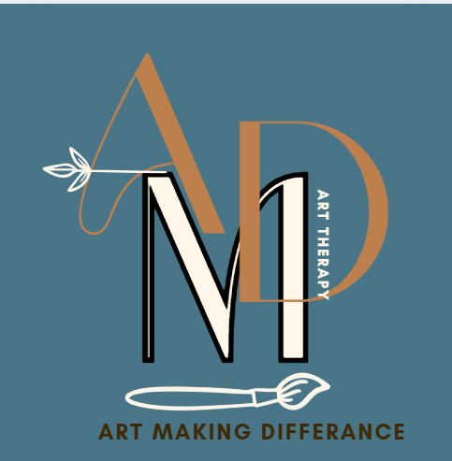
COMMUNITY INTEREST COMPANY
NORTH CUMBRIA – Eden Valley
ARt Making Difference Community Interest company
Registered address: Curlew Cottage Renwick CA10 1JL
Company Number
16424303
Equal Opportunities Policy
Updated 21st June 2025
Review: June 2025
Equal Opportunities Policy – Art Making Difference CIC

1. Policy Statement
Art Making Difference CIC is committed to promoting equality, diversity, and inclusion across all aspects of our work. We aim to create an environment where everyone—staff, volunteers, clients, and community members—is treated with dignity and respect, and where differences are valued.

We oppose all forms of unlawful discrimination and strive to ensure that our services are accessible, inclusive, and responsive to the needs of our diverse community.

2. Purpose of the Policy
This policy outlines how we:
- Promote equality and fairness in employment, volunteering, and service delivery.
- Comply with the Equality Act 2010 and other relevant legislation.
- Prevent discrimination based on protected characteristics: age, disability, gender reassignment, marriage and civil partnership, pregnancy and maternity, race, religion or belief, sex, and sexual orientation.
- Ensure our practices reflect the values of compassion, care, creativity, and collaboration.

3. Scope
This policy applies to:
- All staff (permanent, temporary, freelance)
- Volunteers
- Trustees Supporting Directors
- Service users
- Partner organisations and collaborators

4. Our Commitments
We will:
1. Promote equality and diversity in all areas of our work.
2. Provide a safe, inclusive, and respectful environment free from bullying, harassment, and victimisation.
3. Make decisions based on merit, suitability, and capability.
4. Ensure recruitment, promotion, and training opportunities are fair and transparent.
5. Provide training and guidance to staff and volunteers on equality and safeguarding.
6. Take complaints of discrimination seriously and respond appropriately.
7. Monitor and review our practices to ensure ongoing compliance and improvement.

5. Responsibilities
- Board of Directors: Responsible for ensuring strategic oversight and compliance.
- Designated Safeguarding Lead (DSL): Ensures safeguarding and equality policies are integrated and upheld.
- All Staff and Volunteers: Expected to uphold the principles of this policy and report any concerns.

6. Recruitment and Selection
We will:
- Advertise roles widely and accessibly.
- Use clear, inclusive language in job descriptions.
- Assess candidates based on relevant qualifications, experience, and values.
- Avoid discriminatory criteria or practices.

7. Safeguarding and Inclusion
In line with the Keeping Children Safe in Out-of-School Settings Code of Practice, we:
- Ensure all staff and volunteers are DBS-checked and trained in safeguarding.
- Provide inclusive activities that are sensitive to the needs of children and vulnerable adults.
- Make reasonable adjustments to support access and participation.

8. Monitoring and Review
We will:
- Monitor the diversity of our workforce and service users.
- Review this policy annually or in response to legislative changes.
- Use feedback and data to improve our practices.

