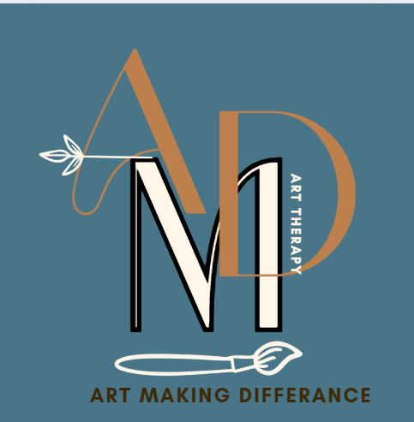
COMMUNITY INTEREST COMPANY
NORTH CUMBRIA – Eden Valley
ARt Making Difference Community Interest company
Registered address: Curlew Cottage Renwick CA10 1JL
Company Number
16424303
COMPLAINTS POLICY
Updated 21st June 2025
Review: June 2025

Complaints Policy

Art Making Difference CIC keeps a central record of all complaints which includes: dates, times, places, name and contact details of complainant, the actual complaint, who dealt with the initial complaint (if made verbally), the outcome and how the complainant was informed of this.
Complaints will always be dealt with seriously, no matter how trivial they may appear.

Complaints Made by Service Users
If a client has a complaint about any aspect of the provision offered them at Art Making Difference CIC, or their treatment when there, they have the option of:
- completing a complaint form which is available to everyone who uses the Art Making Difference Services.
- making the complaint verbally to a staff member

In either case the following procedures will then be followed:

The member of staff receiving / reading the initial complaint should report it to the lead professional, who will in turn pass it to the .

If the complaint is made verbally the client should be asked to write their complaint down (or, if they do not feel willing/able to do so, the member of staff can do this for them and ask them to sign it).

On all occasions the complaint should be reported in the central record via the online incident form:
Online Incidents Form

People who are the subject of a complaint may be by-passed in this process.

Staff cannot expect that their behaviour will always be supported if it is not in the best interests of service users. If a complaint is upheld, the person involved will be informed of the outcome and staff must be aware that a disciplinary action may follow. If any decision is disputed by the staff member, they will have access to relevant grievance procedure with representation. However, it must be stressed that most issues of this kind can be dealt with through negotiation and reconciliation.



Complaints Made by Staff Members
|
Any individual has the right to make a complaint about issues with regards to the organisation, working practice, other employees, management or service users without prejudice.

The procedure for complaints is as stated in the Grievance Policy and Procedure document, which can be found in the employee handbook or is available on request from the Art Making Difference CIC Office.

Any complaint which relates to child protection will be dealt with according to Art Making Difference Safeguarding Policy and Cumberland Council’s Child Protection Guidelines.

External Complaints
Any complaint which is received from outside Art Making Difference CIC must be recorded (to include details of date, time, place, name and contact details of complainant, the actual complaint and who dealt with the initial complaint) via the online incident form:

This record must then be passed immediately to the manager who will investigate the complaint and report to the Supporting Directors. Should the complaint be about the manager it should be referred immediately to the Directors. External complaints should be investigated and a response sent within 30 days wherever possible.

Details of the investigation, the outcome and how the complainant was informed of this, will then be added to the central record.

Related Policies and Documents:
Grievance Policy and Procedure Disciplinary Policy and Procedure Safeguarding Policy

Reviewed- 25/02/25 Signed –  Director | Reviewed- Signed – | Reviewed- Signed – | Reviewed- Signed – | Reviewed- Signed –

